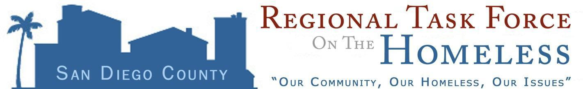

NOTICE TO NON-PROFIT AGENCIES AND UNITS OF GOVERNMENT REQUEST FOR INTENT TO SUBMIT FORM
2018 HUD CoC COMPETITION

Background
To request funds in the homeless Continuum of Care Competition, the U.S. Department of Housing and Urban Development (HUD) requires each local area called a “Continuum of Care” (CoC) to gather and rate local projects and submit one Consolidated Application through a Collaborative Applicant. In San Diego, the Regional Task Force on the Homeless (RTFH) is the Collaborative Applicant.

The 2018 Notice of Funding Availability (NOFA) for the CoC Competition was released on June 20. 2018 A copy of the NOFA and other resources may be found at: https://www.hudexchange.info/programs/e-snaps/fy-2018-coc-program-nofa-coc-program-competition/#nofa-and-notices

Request for Agency Intent to Submit Form
The RTFH requests non-profit agencies or units of government to declare their intent to submit an application for one or more renewal projects, new and expansion projects, consolidated grants, bonus projects, or for reallocation of an existing project. Filing a declaration of interest using the intent form does not obligate the organization to apply, does not guarantee that the project will be included in the Consolidate Application, and does not imply an obligation of funds from HUD, the RTFH, or other sources. Because the 2018 NOFA allows renewal projects to request certain changes, projects currently receiving HUD CoC funds also need to file intent forms and indicate if the agency intends to make changes to the renewal application. For more information about renewal options, please see the HUD NOFA or the NOFA Highlights Summary documents found on the CoC website located at www.RTFHSD.org.

Organizations that wish to submit one or more project applications must submit the attached Intent to Submit Form no later than July 13, 2018. Please note that filing the Intent to submit form is a preliminary step to the application for funds. Potential applicants are encouraged to file Intent forms for any project under active consideration. Intent forms are non-binding and can be withdrawn at a later date.

Types of Projects Eligible to Apply
Local organizations may apply for funds proposed in the following categories as described in the 2018 NOFA.
- Renewal Projects listed on the HUD-approved Grant Inventory Worksheet (GIW), expiring in calendar year 2019 (Permanent Housing, Permanent Supportive Housing, Rapid Rehousing Housing, Transitional Housing, Joint TH-RRH, and Safe Haven)
- New Rapid Rehousing for individuals, families, and unaccompanied youth
- New Permanent Supportive Housing for individuals, families, and unaccompanied youth

- Joint Transitional and Rapid Rehousing project renewals
- Domestic Violence Bonus Projects
- Consolidated Grants merging existing projects of the same type
The RTFH as the Collaborative Applicant and HMIS Lead Agency can also apply for HMIS dedicated projects, the Coordinated Entry System, and a non-renewable CoC Planning Grant. Reallocation means an agency or organization currently using HUD CoC funds is requesting that some funds from an existing grant be used to apply for a new, eligible project. This is also referred to as ‘self-reallocated’. Reallocation also means funds that are made available through the CoC local review process to fund new and/or expanding projects.

Please note:

- The level of funds available for new projects has not yet been determined. Please consider if your project could be ‘scaled’ to various levels of funding.
- Each project must match 25% of project costs. This may be achieved through cash or in-kind contributions but must be documented in the application and supported by a letter of commitment dated in accordance with the NOFA.
- Appropriate documentation of site control is required at the time of application.
- Although new projects applications may include plans to construct, acquire, or rehabilitate facilities requests for HUD CoC competition funds for these costs reduce the ongoing funding available to the CoC. These costs should be supported by resources other than the CoC NOFA. Projects that create housing through other resources are desirable and reviewed in the local scoring process.

The Intent to Submit forms will be screened for eligibility. Final project eligibility requirements are contingent upon guidelines described in the 2018 HUD Request for Applications. All eligible projects seeking funds through the 2018 CoC program competition will be required to submit a full proposal application in accordance with local requirements and HUD guidelines as required in the NOFA. Questions regarding the completion of the Intent to Submit Form can be submitted to the NOFA Technical Assistance team via e-mail to: Deme.Hill@RTFHSD.org and PLeslie@PointLoma.edu.

Forms must be received by 5:00 pm, July 13, 2018 to the Documents Used by Multiple Projects your agency’s 2018 NOFA Dropbox.
If your organization is new to CoC NOFA funding, please contact the NOFA Technical Assistance Team below and a Dropbox will be created for you.
Email: PLeslie@PointLoma.edu
or via U.S. Postal Service:
Regional Task Force on the Homeless
4699 Murphy Canyon Road
San Diego, CA 92123
ATTENTION: Deme Hill - 2018 CoC NOFA

Thank you
Filing this Intent to Submit Form assists the region in planning for success in the national competition bringing vital funds and programming to end homelessness in San Diego. Thank you for expressing your interest in the 2018 Continuum of Care Competition for New Projects.

