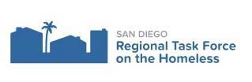

General Membership Meeting

AGENDA
Date: September 9, 2021 |  | Time: 10:30 am - 12:00 pm | Location: Join Zoom Meeting https://us02web.zoom.us/j/88354454160  Meeting ID: 883 5445 4160
Agenda |  |  | Presenter
1 | Welcome |  | Tamera Kohler | 5 mins
2 | Public Health/County of San Diego Update |  | Dr. Wooten | 10 mins
3 | Funders Together & Mixte Communications |  | Amy Denhart | 5 mins
4 | 2021 NOFO Update |  | Pat Leslie | 30 mins
5 | Senior Homelessness Report |  | Paul Downey and  Melinda Forstey | 15 min
6 | RTFH Data Dashboards |  | Jegnaw Zeggeye | 15 mins
7 | Regional Plan Draft Comments and Input |  | Kris Kuntz | 5 mins
8 | Open Forum/Community Updates |  |  | 5 mins
Informational Items:
Next General Membership Meeting: October 14, 2021. 10:30 am – 12:00 pm.
Location: Zoom Videoconference

